Project Proposal:

Description: My project name would be Type and Learn. Since there are more online testing and assignments now, the project is designed to help the users increase their typing speed as well as be familiar with English vocabulary. Users could login with their account locally, practice typing, test their speed, and review the words they typed using my project. They could also view the scoreboard for each level with all local users and their scores.

Competitive analysis: Some popular typing games I’ve seen online only let the users to type a single letter. My project allows the user to type a full word with different difficulty levels. Also, there would be speed test mode to let the user realize their progress after levels of practice.

Moreover, my project could be used for education purpose. Users could review the words and the meanings of the words they’ve typed.

Structural plan: The finalized project would have the following features:

* + Having different levels of typing games
  + Let the user test their typing speed
  + Store the user’s information and retrieve the words they typed and their meanings

I’ll create separate files for these functions, with a main file that does all drawing work and the major feature—typing games levels. A file stores user’s information—age, password, words they typed and another file with all classes.

Algorithmic plan: The difficult part for my project might be determining which word they are typing for after pressing a key and change color for the typed letter. For example, there might be multiple words with the letter ‘r’ on the screen. The user should only type the letter in sequence and one word per time, so the letters would only appear red if the previous letters are typed. I plan to approach this feature by creating a new list that contains every letter typed and compare this list to the words on screen. The word would be reset a letter is typed wrongly and the list would be emptied. Another tricky part would be designing the physics engine when the bubbles collide and bounce. I plan to refer to the collision formula and figure out the direction and speed the ball would have after collision.

Timeline plan: I’ve made a timeline on Trello and here’s the screenshot.

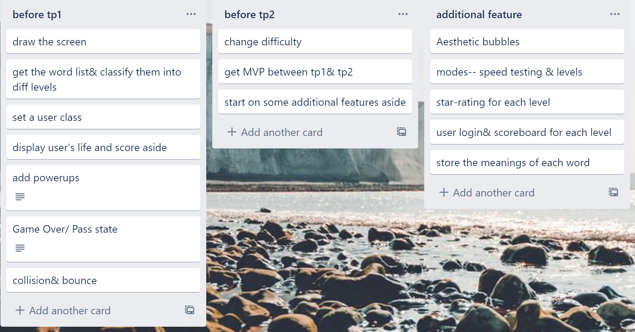

Version control plan: I’m uploading my term project folder every 12-16 hours to the Google Drive if I make some edits on it. Also, I’m backing up my files to a USB every time I finish my work for that day.

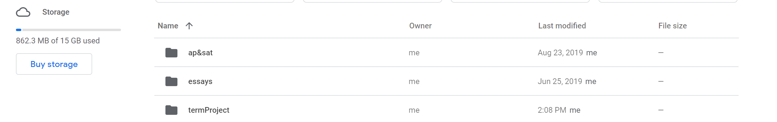

Module List: I’ll not be using any external modules before MVP.

TP2 update: None

TP3 update:

My project will no longer have features that test typing speed or review the typed word/ meaning. Instead, I added the user login page and the scoreboard, which stores all scores/ users/ levels in local txt file. I have also added the main page, containing a map of all levels. The user could choose level to play and unlock further levels on the map based on the score of previous level. Level attributes (speed, word length, etc.) would be assigned accurately when entering the level.

Also, for algorithm part, another complex part would be the user performance analysis. I stored the percentage of each letter being typed wrong and created an index for every word in the wordlist. Then, I generate word based on the index.